**CIST 1305 Development Processes**

| **Software Development Cycle** | **Systems Development Life Cycle** |
| --- | --- |
|  | Planning |
| Requirements | Analysis |
| Design | Design |
| Implementation | Implementation |
| Verification |  |
| Maintenance | Maintenance |

**Spiral Model –** is used for large, complicated projects.

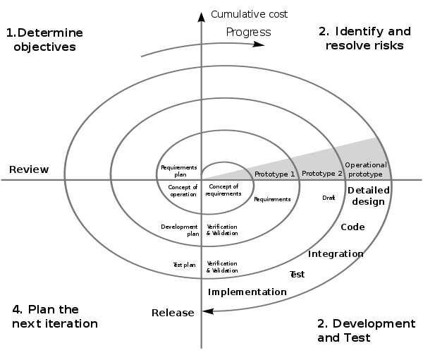

Source: http://en.wikipedia.org/wiki/Spiral_model